

|  |  |  |  |  |  |  |  |  |
| --- | --- | --- | --- | --- | --- | --- | --- | --- |
|  | | | | | | | | |
|  | | Taripp Trader | | | | |  | |
|  |  | | | | | | |  |
|  | | | |  |  | | | |
|  | | | | Huan Nguyen |  | | | |
|  | | | | March 14, 2025—Database Management & Warehousing—Dr. LaBrie Ryan C. LaBrie, Ph.D. |  | | | |
|  | | |  | | |  | | |

#### Business Justification

In today’s fast-paced financial markets, managing trade records is crucial for traders, brokers, as well as financial institutions. Without a well-structured database, any mistakes when recording trades manually can lead to errors, inefficiencies, or financial losses. This trading system database is designed to provide an automated solution for trading management while ensuring accuracy, security and efficiency.

**Current Problem:**

* Insufficient trade tracking: Without the centralized database, trade records are prone to human errors
* Data inconsistencies: without relational integrity, data duplication or incorrect information can lead to poor decision making and financial losses
* Manual reports are time-consuming and inefficient

**Recommendation:**

* Automated trade entry:
  + Users’ trades will be recorded whether it is a buy or sell order with real-time validation.
  + The system will also make sure that the trade is well linked with brokers, traders, and assets.
* Real-time portfolio tracking
  + Displays if traders are holding any positions by calculating total buy and sell for each asset.
  + Keep track of the latest updated market price as well as showing trade hours
* Optimized broker management
  + Ensures brokers are linked to trades – effective when tracking for commission
* Accurate trade reports & data integrity
  + Easy to generate reports for portfolio performance, account balance as well as trade history
  + Ensures referential integrity to prevent invalid transactions

**Outcome**

* Increased efficiency: automates trade entry while reducing manual errors
* Better decision making by providing real-time insights into trading performance
* Improved compliance: maintains structured and accurate trade record
* Scalability: can be replicated and expanded to include more financial instruments and risk management features.

#### ER Diagram

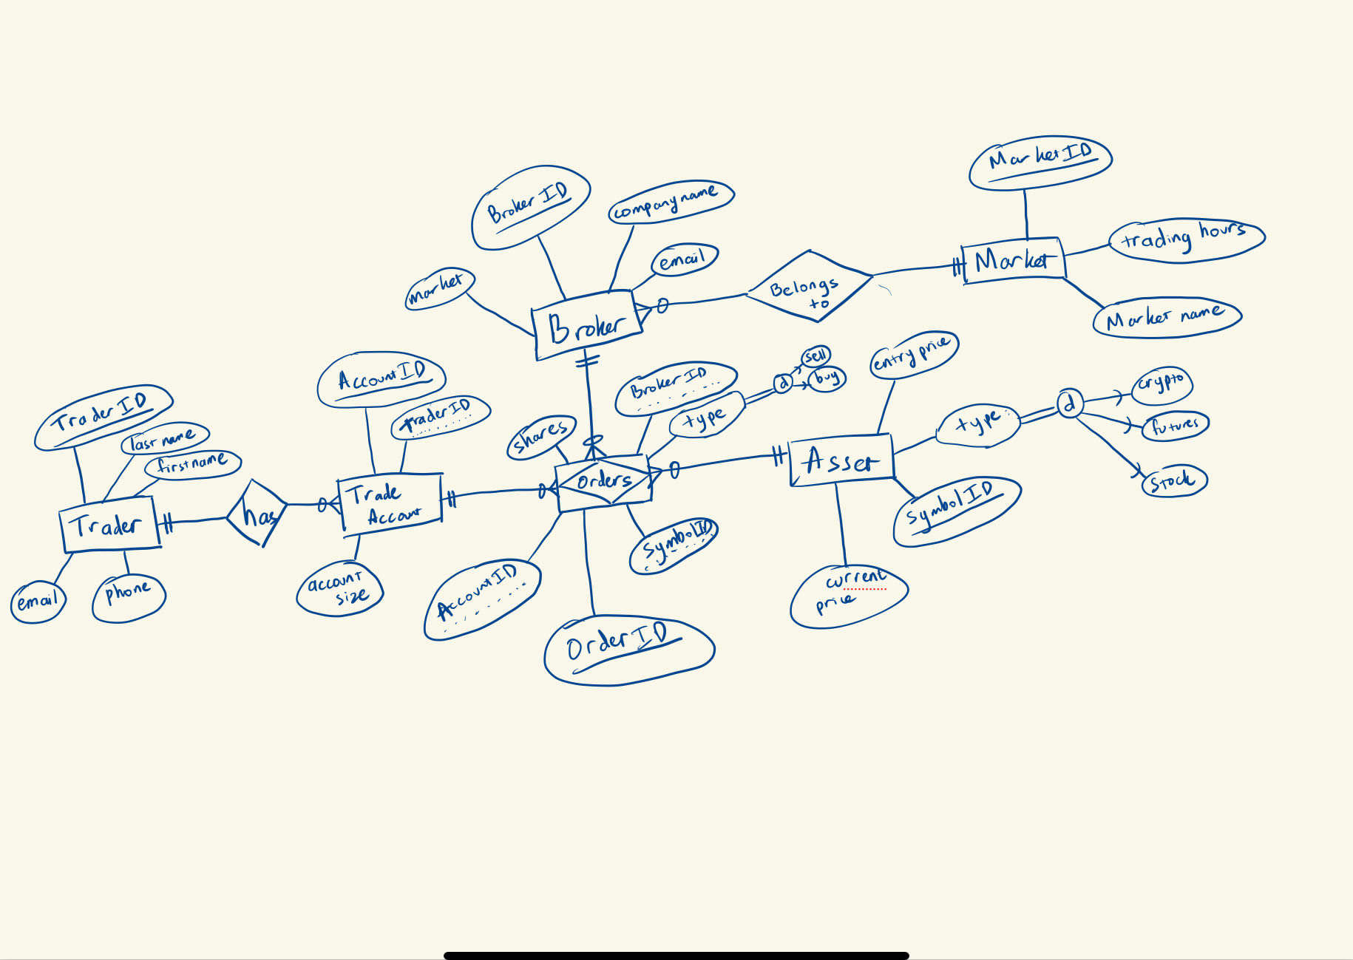

#### Relational Schema

#### The 3 W’s

* **What went well?**
  + I got to create my own database
  + Creating my own project, trying things that I learn from class into real-life projects
  + I’m surprised that I can finish the project by myself. This would be my very first baby and, in the future, I would definitely look back on where I was when first started
* **What did not go well?**
  + When I first started the project, because I’m really interested in trading, I have so many ideas about creating a centralized database. Then, I started to make the project over complicated.
  + The first ERD that I sent you, when I started on Microsoft Access, I saw lots of issues such as naming entities or putting attributes.
  + I struggle with order types such as buy and sell shares
* **What would I do differently next time?**
  + Next time, I will definitely start the project sooner and ask you for some advice.
  + Maybe I can add more attribute related to broker like their commission per order. For remaining shares, price for “future” shares would be different. They count by tick and a tick (0.25) for ES would be $50 and 0.25 for NQ would be $20.
  + I also want to add in “option”, and they would have beginning and expiration date.
  + Entry price and sell price would have a date or timeline for each transaction.